I)One Java application can interact with multiple & different database software at a time.

**UseCase-1:-** If Bank-1 acquires the Bank-2 then account holders information of bank-2 should be copied into Bank-2 DB.

Example:- Canara Bank acquired the Syndicate Bank. The Account holder information of Syndicate bank has been copied into Canara Bank DB.

**UseCase-2:-** Transfer Fund from One kind of Bank Account(SBI) to another kind of Bank Account(ICICI).

**II)**  In single JDBC app, we can create multiple JDBC Connection objects, Statementobjects and Resultset objects as needed.

**Example:- Write a JDBC application to copy the product table records from oracle DB to MySQL DB.**

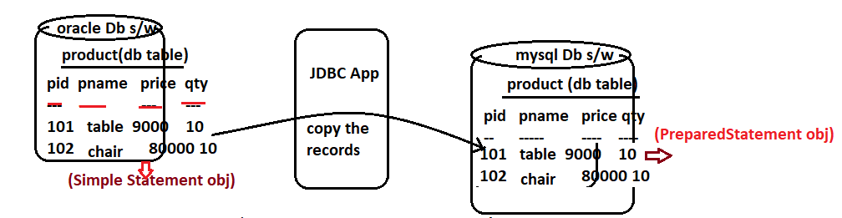

**Note:-** we get all records from product table only once. The java application need to execute “SELECT STATEMENT” only for 1 time. For this, we should use “Simple Statement”.

After getting all records, JDBC application has to insert them one by one by executing “INSERT” command. For this we should use “Prepared Statement”.

